Title: Updating the firmware (Image) using network method on the LS9.
Description: This test script will update the firmware through a network method called webpage method. We can update LS9 image or Chrome image separately single time or multiple times or both Network and Chrome images for single time or multiple times using Scripts. We can upgrade and downgrade firmware (Handled in webpageupdate.py file). Script will read the IP address, Firmware Version from the terminal. If the DUT is not connected to the network, Script would connect to the network. Parallelly logs will collect using multithreading module. First it will ask user update options. It will ask for the update count, based on the options it will ask type of update based on those scripts will ask factory reset options. Once the selection page is done later it will start the update process based on the update count and method which we will select in the beginning. For Each run Script will read the IP address, Firmware version from the terminal. For Chrome update (Option2) will happen based on the current firmware version like if the Firmware version is 1.44 it will update the 1.44 Chrome image if the firmware version is 1.52 it will update 1.52 Chrome image. For each update it will give the Firmware update iteration count and by seeing this count we can decide how many times firmware got updated. During the cast shell mismatch, during different laptop network, off state cases and failed update handled in upgradeanddowngradeloop.py script.
Pre-conditions to use the scripts.
1 Install python.

2 install selenium.

3 install the webdriver_manager .

4 We need to place the 83-network image and OTA images in script path (Where you will keep the scripts that path) and the Network image name should be “83_IMAGE_network” and OTA images should be castota152 for 1.52, castota144 for 1.44, castota136 for 1.36 and castota128 for 1.28. This is for updating the same image in loop (refer the file webpageupdate.py).

5 We need to place the two 83-network image and OTA images in script path (Where you will keep the scripts that path) and the Network image names should be “83_IMAGE_network_1”, “83_IMAGE_network_2” and OTA images should be castota152 for 1.52, castota144 for 1.44, castota136 for 1.36 and castota128 for 1.28. This is for updating the two images (refer the file upgradeanddowngradeloop.py)

6 For upgradeanddowngradeloop firmware update we need to rename the data file which consists of current firmware and new firmware to which firmware you want to update.

7 Change the COM port number in serialcommunication python file.

8 Change the ssid and password in the configuringdutusinglucicommand() function of the serialcommunication python file.

8 Run the script
- py Launcher.py from the terminal for Windows
- python Launcher .pyfor Linux

9 script paths will look like below.
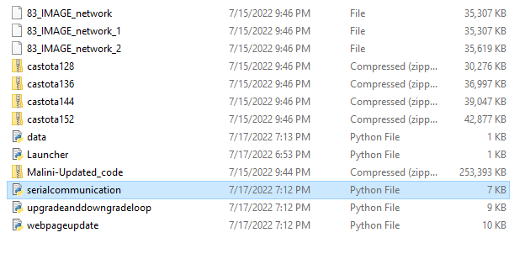

Output: Output will look like below.

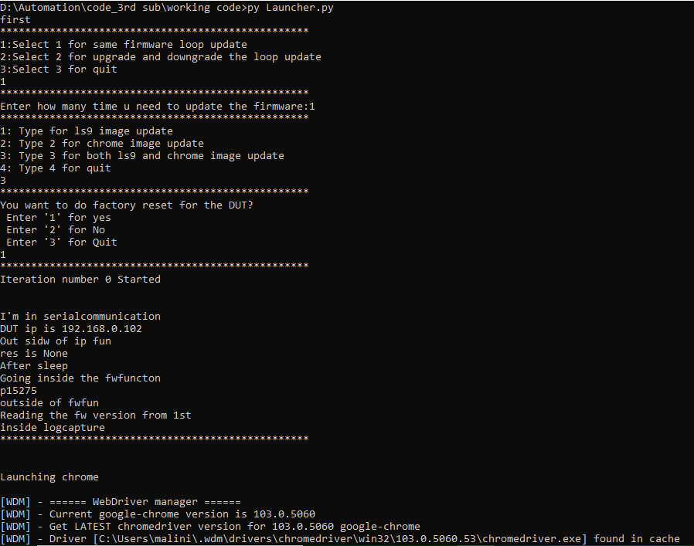
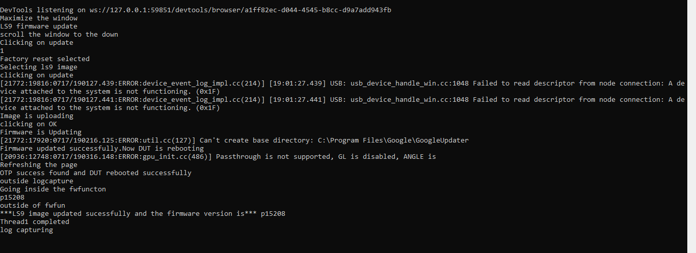
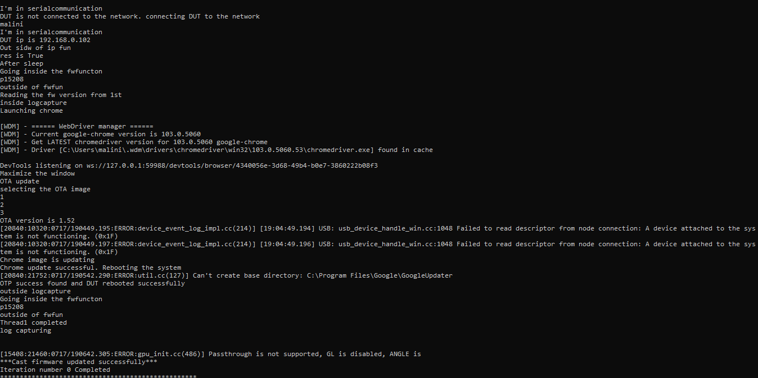

Advantages
1 Multiple time we can update the firmware.
2 Reduce the time and efforts

Newly implemented features_code version_3.0.
1 Need to save the logs
>>Fixed. Parallelly logs will save.
2 Need to handle the fail case.
>>Fixed. If this is failed it will give the error.
3 It should print the FwVersion of the updated firmware.
>>Fixed. Reading this from the tera term.
4 It updates like 1000 to 10001.
>>Fixed. We can do downgrade and upgrade.
5 Connect to network.
>>Fixed. DUT will connect to the network when in the setup mode.
6 Unit test, Scripts should not exit.
>>Fixed.

